**CN ASSIGNMENT (FILE TRANSFER)**

NAME: Ch. Shreya Chowdary

ROLL NO: SE20UARI142

**AIM:** To develop the file transfer application using TCP sockets.

**SENDER**

* Sender creates a new server socket.
* Sender accepts the client connection
* Sender opens the file and transfers the data.

**RECEIVER**

* Receiver tries to connect to the socket
* Receiver transfers the details of the required files.
* Until the file is received, the receiver continues to receive
* Time spent sending and receiving is recorded.
* The file transfer is done successfully.

**FOLDER BEFORE TRANSFERING**

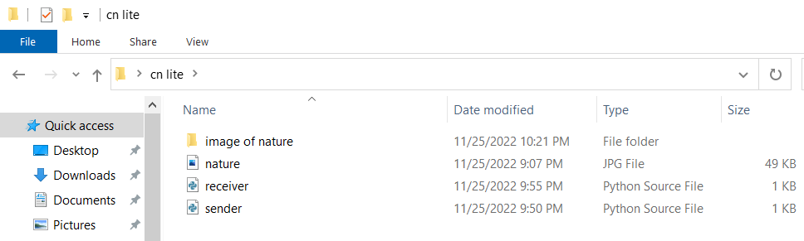

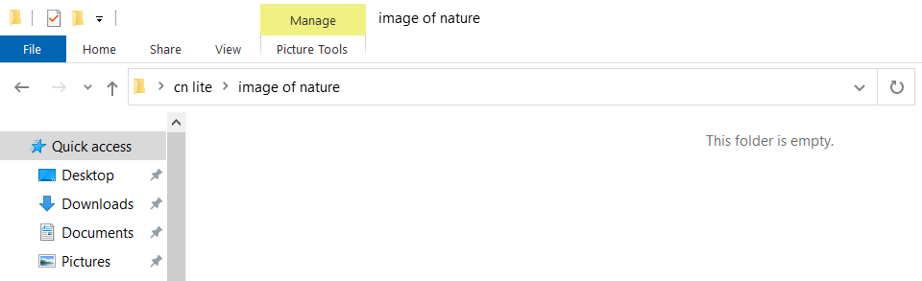

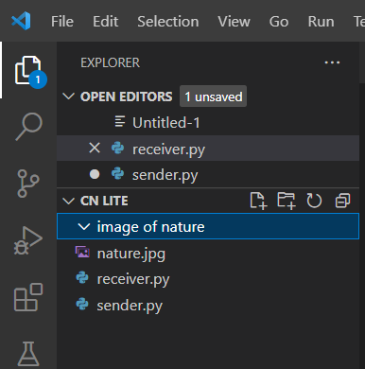

**TERMINAL**

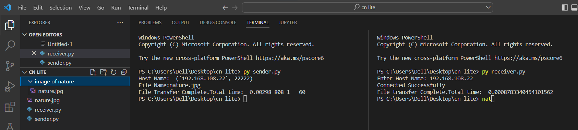

**FILE TRANSFERRED SUCCESSFULLY**

